**DZC20 Report**

Small Team 3

Kağan İslamoğlu, Marcin Macierzanka



**What is TU/e-ch Grass?**

TU/e-ch Grass is an innovative first-person 3D puzzle/escape room game designed to introduce players to the basics of the world of computer science. The game is set within the ground floor of an abandoned office building divided into three distinct sections. These 3 sections are Mathematics, Logic, and Programming mirroring the structure of courses of computer science at Eindhoven University of Technology (TU/e), where students often tackle courses from each of these fields every quartile. The player’s ultimate objective? To touch grass – a playful reference to the ongoing stereotype that computer scientists spend all their time indoors in complete darkness, unwilling to go outside and connect with nature.

The moment the game begins, the player is hit with the final goal spread across the entire screen: "TU/e-ch Grass", immediately making the player aware of the what they must achieve. The player begins in a dark, central room and is initially positioned facing a blocked off window and highlighted console aimed to be the first thing that grabs their attention. Upon interacting with the console, the window is uncovered revealing a beautiful field of luscious, green grass on the outside, further solidifying in the player the overarching goal of the game. To unlock access to the outside, the player must solve puzzles in each of the three sections of the map. Successfully completing these challenges rewards the player with pieces of a QR code. When assembled, the QR code provides the key to finally opening the window and allowing the player to reach the goal of touching grass.

**Main Mechanics**

1. **Exploration and Puzzle Solving:** Players navigate three themed sections of the map: Mathematics, Logic, and Programming. Each section contains hands-on, action-based puzzles that encourage players to think critically and creatively and learn about the different concepts in each section.
   * **Mathematics Section:** Solve puzzles based on probability, graphs, and matrices.
   * **Logic Section:** Learn about the different boolean operators.
   * **Programming Section:** Experiment with algorithmic thinking and basic coding concepts.
2. **Progression Through Discovery:** Completing puzzles grants pieces of the QR code that opens the exit, representing milestones in the player’s journey. The game’s design encourages curiosity as clues to help learn and solve different puzzles are spread around the map.
3. **Immersion and Interactivity:** Players collect items, manipulate objects, and interact with the environment to solve puzzles, giving players a real sense of control and pride in their achievements. The player is free to interact with the objects within the world in any way they like with little obstruction, enhancing the puzzle aspect of the game and promoting critical thinking.
4. **Lighting:** In the lectures, lighting was mentioned as a way to guide the player to places they are supposed to go to. Since in our game the player is free to choose the order of progression, lighting is instead used as a “checkpoint”, where it indicates the places the player has already been to, in order to avoid confusion. The player is instead guided through other means such as glow in the dark signs and a means to light up anywhere (a flashlight and light switches in rooms they have been in).

**Target Group**

The target audience for TU/e-ch Grass are primarily high school students, particularly teenagers considering their future university studies who have a liking for a mathematics and general problem solving. This group often seeks engaging ways to explore potential fields of interest, making interactive experiences like this an ideal way of presenting the concepts of computer science. The game’s playful approach to computer science aligns with their natural curiosity and fondness for digital entertainment. Also the game serves the purpose of teaching some of the basic aspects of computer science to teenagers that are curious about what the study itself is like, allowing them to make a more educated decision in their academic career.

**Why Will They Like It?**

1. **Relatable Humor:** The concept of touching grass taps into meme culture – something that resonates deeply with most teenagers. This comical addition to the game can therefore increase overall engagement and retention in educational settings, along with enticing teenagers who might have heard to game to play it.
2. **Gamified Learning:** The puzzles in TU/e-ch Grass are designed to subtly introduce fundamental concepts in mathematics, logic, and programming, making the game both fun and educational as gamification has been shown to improve motivation and learning outcomes, especially among younger audiences.
3. **Sense of Achievement:** Completing puzzles and assembling the QR code step by step with each puzzle provides a clear sense of progression and accomplishment. This feedback loop is crucial for sustaining motivation and developing a positive learning experience.

**Addressing the Stereotype**

We are fully aware of the negative aspect of the stereotype that computer scientists are socially isolated and "don’t touch grass". However, knowing the target group are teenagers, most likely aware that this is just a joke rather than an accurate description of computer scientists, they are likely to find this as more of a playful addition, rather than see this as a legitimate reason not to go on to study computer science, which was proven to be true through the feedback we received from fellow students after our concept presentation.

**Gameplay**

As mentioned previously, our game starts with a popup that sets the ultimate goal of the game, and a spotlight shining light on the QR code scanner required to exit the building and achieve said goal, which is within the line of sight of the player seen in Figure 1. We believe that naturally, the player will be gravitated towards said scanner, where in doing so, the grass that they are supposed to touch is revealed and the main room is lit up in a dramatic fashion with the curtains rising slowly accompanied by lights turning on one by one, shown in Figure 2 and Figure 3.

After interacting with the QR scanner and learning the means of achieving the end goal of the game, the player is greeted with three rooms (Figure 4), and a flashlight which sits on a table nearby (Figure 5).

**In the logic room,** the player will first come across a door, behind which a piece of the QR code sits, and two guards blocking the door, where the guards will ask for various types of food, but using logic symbols instead of words (Figure 6). The player is tasked with understanding what the symbols mean and how to satisfy their conditions. Across the guards there is a kitchen with the necessary items for the guards and a sign that briefly explain what each symbol means, in order for the player to understand the task and therefore working principle of logic gates used in computer science (Figure 7). After both guards are satisfied with the food available to the player, the door will open revealing the QR code (Figure 8). There also lies a piece of a vector required for the math room that the player can pick up in the kitchen.

**In the math room,** the player has to open a locked door in order to access the QR code piece, and to do that the player needs to find the missing vector pieces in order to compute a 2x2 matrix (Figure 9). These vector pieces are scattered around the map, but one is not reachable until the player completes the math puzzle (Figure 10) where the player needs to create a curve such that it touches two areas simultaneously.

Upon collecting all the QR code pieces, which actually links to TU/e computer science and engineering application page as an easter egg, the player can finally exit the building, and be faced with a flat and endless field of grass featuring a liminal space aesthetic and the awe inspiring sight of the impossibly large building where they just exited, where then it is revealed to the player that they have been playing a game within a game with the main character is seen removing their VR headset (in a building such as Atlas) and starting to code the game that they have been playing with the camera panning to the TU/e campus with the sun setting in the skyline of Eindhoven.

**Learning Goals**

The goal behind our game is to make an introduction to Computer Science concepts at TU/e and to showcase what the courses in the beginning of a computer science students’ look like. So the learning goals of our game include basic coding concepts, algorithmic thinking, Boolean logic fundamentals, matrix operations and graph theory basics / geometric thinking. These concepts are introduced through interactive puzzles that mirror real computer science courses. Boolean logic challenges teach logical operators, while algorithmic thinking tasks develop problem-solving skills essential for coding. Matrix operations and graph theory are explored through spatial reasoning and mathematical puzzles, reinforcing fundamental computing structures. Geometric thinking is integrated into vector-based tasks, highlighting real-world applications. By experiencing these concepts in a gamified environment, players gain a fun and engaging preview of the foundational topics in computer science at TU/e.

The game is designed by following constructivist learning principles, where players actively construct knowledge by engaging with the given tasks. According to Piaget’s theory of cognitive development, learning is most effective when individuals interact with their environment to solve problems. The puzzle-based structure of the game ensures that players are not passive recipients of information but rather actively engage with key computer science concepts, promoting deeper understanding and retention. Each section—Mathematics, Logic, and Programming—introduces various concepts, allowing players to build on their knowledge and potentially apply the knowledge in the future. Situated learning theory (Lave & Wenger, 1991) further supports this approach by providing players with an environment that simulates real-world problem-solving, reinforcing the applicability of these concepts beyond the game.

Our game fosters persuasion by incorporating central route processing from the Elaboration Likelihood Model (Petty & Cacioppo, 1986), ensuring players have a change to engage with computer science concepts through problem-solving. By directly interacting with puzzles and receiving immediate feedback, players are encouraged to reflect on the mechanics behind logical operators, algorithmic thinking, and matrix operations.

The Fogg Behavior Model (2009) aligns motivation, ability, and triggers by ensuring that puzzles are engaging, solvable, and clearly explained. Additionally, narrative transportation theory (Green & Brock, 2000) is used to immerse players in the storyline, reinforcing the message that computer science is dynamic and rewarding. The climactic reveal—that the entire game was played in VR—serves as a memorable twist, potentially increasing the persuasiveness of the invitation to TU/e computer science through the means of memorability.

The game’s persuasiveness is enhanced by humor, autonomy, and immersive design, making it relatable and motivating for the audience. The inclusion of meme culture makes the game engaging for younger audiences, while the open-ended nature of exploration encourages a sense of agency. The clear milestone system, where players collect QR code fragments, provides positive reinforcement, sustaining engagement. However, some factors could hinder persuasion. If the puzzles are to be designed too hard, high cognitive load due to complex puzzles might lead to frustration, potentially discouraging players unfamiliar with computer science concepts. There is also a risk that the stereotype of computer scientists not touching grass, despite being framed humorously, might be misinterpreted as a negative portrayal rather than a playful reference. Lastly, a lack of adaptive difficulty may cause disengagement for players with varying levels of prior knowledge. Refinements such as clearer hints, adjustable difficulty settings, and additional scaffolding could enhance both the learning experience and the game’s persuasive power, ensuring that TU/e-ch Grass effectively inspires interest in computer science.

**Appendix**

Figure 1: Main room at boot

Figure 2: Player view at boot

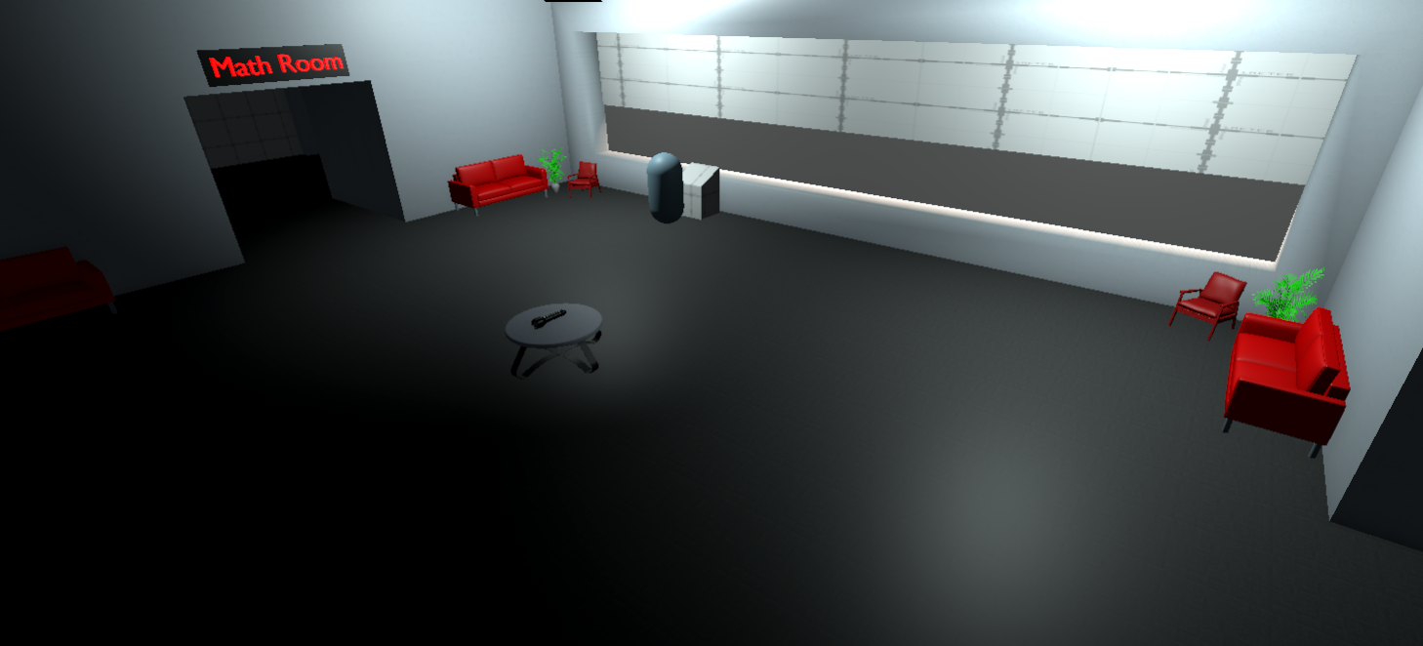

Figure 3: Shortly after interacting with the scanner

Figure 4: Player view after interacting with the scanner for the first time

Figure 5: Flashlight on table

Figure 6: Logic room guards

Figure 7: Logic room kitchen

Figure 8: Satisfied guard

Figure 9: Math room locked door

Figure 10: Math section puzzle room, showing the locked matrix piece and the prompt upon interacting with the puzzle